

Crossroads   
Release Notes

Release 6.24.20

Revision 1.6

07/15/2014

**Code Release Checklist**

Product/Application/Service: Crossroads

Release Notes: __X__

Build Kit Identification: _Crossroads6.24.20 _________________

Directory/Table changes required: None

Scheduled Release Date: 07/20/2014

OS release is being tested with: Linux

OS patch version level _RHEL5.6 2.6.18-238.5.1.el5

Third party software version:

System Test: Development:

Iplanet Web Server 7 SP6 Iplanet Web Server 7 SP6

Iplanet Directory Server 5.2 Iplanet Directory Server 5 SP2

Proxy Server: OHS 11.1.1.7/ Proxy Server: OHS 11.1.1.5/

Apache 2.2.15 Apache 2.2.15

Java JDK 1.6.0_24 Java JDK 1.6.0_24

Development Resource On Call:

Name: Gaurav Sharma (Primary)

Phone: 813-610-1082 (Mobile)

813-774-4552 (Home)

Name: Sarath Mani (Secondary)

Phone: 813-484-0016 (Mobile)

813-333-5822 (Home)

Name: Jim Paauw (Secondary)

Phone: 813-493-2467 (Mobile)

727-527-3195 (Home)

Tested

Browser levels _____ IE 8.0 _____

Testing Completed By: _Centralized Test –

Comments: Please list any dependencies that this release may have in relation to other aapplication(s) releases.

Analyzer : Analyzer SMS 1.05.00 , ER_ANZ_MSG 1.00.00

OCSMS

**Revision History**

|  |  |  |
| --- | --- | --- |
| **Revision Number** | **Date** | **Reason** |
| 1.0 | 06/22/2014 | Initial Release |
| 1.1 | 06/27/2014 | Updated |
| 1.2 | 06/30/2014 | Updated. |
| 1.3 | 07/02/2014 | Updated ocsms2 proxy with /oc/ |
| 1.4 | 07/07/2014 | Updated anzanm2 proxy configuration |
| 1.5 | 07/14/2014 | Removed oc/ from ocsms2 proxy |
| 1.6 | 07/15/2014 | Updated as per Jim comments. |

**Table of Contents**

1 Release Overview 5

1.1 Overview 5

1.1 OCSMS2 [PR_4426] 5

1.2 Customer Impact 5

1.3 Processor Impact 5

1.4 Data Impact 5

1.5 Interfacing or Related System Impact 5

1.6 Network Impact 6

1.7 Data Center Impact 6

2 Changes 7

2.1 Tables/Files 7

2.2 Job Processing 7

3 Implementation Tasks 7

3.1 Release Procedures 7

3.1.1 Pre-Release Requirements 7

3.1.2 Crossroads – Director 8

3.2 Backout Procedure 11

3.3 Monitoring/Verification Procedures 11

3.3.1 OCSMS2 [PR 4426] 11

• Syniverse Company 11

• Syniverse User 13

• Customer Test Company 18

• Customer Test Company User 20

4 Test Procedures 25

# Release Overview

## Overview

This release includes the following:

## OCSMS2 [PR_4426]

**The OCSMS2 functional design document explains all the functionalities related to PR 4426 items.**

**Here is the Design document link:**

[**http://central.syniverse.com/sites/TECH/arch/Crossroads/_layouts/WordViewer.aspx?id=/sites/TECH/arch/Crossroads/Release%20Documentation/Crossroads%20Design[OCSMS-PR4426].docx&Source=http%3A%2F%2Fcentral%2Esyniverse%2Ecom%2Fsites%2FTECH%2Farch%2FCrossroads%2FRelease%2520Documentation%2FForms%2FCustom%2520Group%2520View%2Easpx%3FGroupString%3D%253B%25236%252E24%252E20%253B%2523Design%253B%2523%26IsGroupRender%3DTRUE&DefaultItemOpen=1&DefaultItemOpen=1**](http://central.syniverse.com/sites/TECH/arch/Crossroads/_layouts/WordViewer.aspx?id=/sites/TECH/arch/Crossroads/Release%20Documentation/Crossroads%20Design%5bOCSMS-PR4426%5d.docx&Source=http%3A%2F%2Fcentral%2Esyniverse%2Ecom%2Fsites%2FTECH%2Farch%2FCrossroads%2FRelease%2520Documentation%2FForms%2FCustom%2520Group%2520View%2Easpx%3FGroupString%3D%253B%25236%252E24%252E20%253B%2523Design%253B%2523%26IsGroupRender%3DTRUE&DefaultItemOpen=1&DefaultItemOpen=1)

**Note: Please check the Section 4.3 MONITORING/VERIFICATION PROCEDURES for more description and screen-shots.**

Risks

## Customer Impact

None

## Processor Impact

Negligible

## Data Impact

None

## Interfacing or Related System Impact

OCSMS

Analyzer : Analyzer SMS 1.05.00, ER_ANZ_MSG 1.00.00

Crossroads release can be installed first, but the Analyzer related perms will not be available until Analyzer release is installed.

If OCSMS release is not installed then OCSMS related links will not work.

## Network Impact

None

## Data Center Impact

No additional impact.

# Changes

## Tables/Files

No changes.

## Job Processing

No changes.

# Implementation Tasks

This section describes in detail the steps that need to be performed to install this software release. Each step should be completed and verified before proceeding to the next step. Any queries should be directed to the development team.

## Release Procedures

#### Pre-Release Requirements

##### DNS Requests

##### Request the following DNS entries as CNAMEs to crossroads.syniverse.com:

* ocsms2-xrds.syniverse.com [PROD]
* anzanm2.syniverse.com [PROD]

**Functional User ID**

No new functional ID is required.

#### Crossroads – Director

|  |  |
| --- | --- |
|  | **Software Install** |
| Note: | **Crossroads release can be installed first, but the Analyzer related ANM links will not work utill Analyzer release is installed.** |
|  | **Web Tier – httpd.conf** |
|  | Make backup copies of the httpd.conf files. |
| Step 1 | **Edit the httpd.conf files and add the following lines:**  **<VirtualHost *:7777>**  **ServerName ocsms2-xrds.syniverse.com**  **SetHandler ccv**  **ProxyPass /** <http://HOST:PORT/> **[Please check with OCSMS Ops]**  **ProxyPassReverse /** <http://HOST:PORT/> **[Please check with OCSMS Ops]**  **</VirtualHost**>  **<VirtualHost *:7777>**  **SetHandler ccv**  **ServerName anzanm2.syniverse.com**  **<Location />**  **order allow,deny**  **deny from all**  **</Location>**  **<Location ~ "/(analytics|theServlets)">**  **order deny,allow**  **allow from all**  **SetHandler weblogic-handler**  **RequestHeader set IS_SSL ssl**  **RequestHeader set WL-Proxy-SSL true**  **WebLogicCluster** <HOST:PORT/>, [HOST:PORT/](http://HOST:PORT/) **[Please check with ACCWEB/ANZ ops]**  **</Location>**  **</VirtualHost>** |
| Step 2 | Restart the OHS proxy server:  **Stop OHS instance (if applicable):**  #opmn-stop  #opmn-start |
| Step 3 | Transfer the tar file from hwcmb01:  /ccm_builds/crossroads/release_output6.24.20/2014MMDD/*CrossRoads6.24.20.2014MMDD.tar*  to the application tier servers.  The exact file name will be provided in the signoff email.  **Production steps:**  **As your own ID:**  # cd /tmp  # scp hwcmb01:/ccm_builds/crossroads/release_output6.24.20/2014MMDD/CrossRoads6.24.20.2014MMDD.tar .  # ssh hwcmb01 cksum /ccm_builds/crossroads/release_output6.24.20/2014MMDD/CrossRoads6.24.20.2014MMDD.tar  # chmod 777 CrossRoads6.24.20.2014MMDD.tar  **sudo to xroads**  # sudo su - xroads  **Move the release tar to /share1/xroads/releases:**  # cd /share1/xroads/releases  # mv /tmp/CrossRoads6.24.20.2014MMDD.tar .  # cksum CrossRoads6.24.20.2014MMDD.tar  **Ensure the cksum's match.** |
| Step 4 | From the /crossroads directory, extract the contents of the tar file from the Crossroads 6.24.20 build.  tar -xvmf CrossRoads6.24.20.2014MMDD.tar  **Production steps:**  # cd /crossroads  # cp /share1/xroads/releases/CrossRoads6.24.20.2014MMDD.tar .  # tar -xvmf CrossRoads6.24.20.2014MMDD.tar ./cgi-bin/GenerateLDIF  # tar -xvmf CrossRoads6.24.20.2014MMDD.tar ./cgi-bin/grantPermissions |
|  | **LDAP Scripts** |
| Step 1 | Execute the following command from the /crossroads/cgi-bin directory:    ./GenerateLDIF OCSMS2 |
|  | **Import LDIF files into LDAP Directory** |
| Step 1 | **Production:** FTP the ldif files from the previous step to the LDAP Directory server - crossroads-dir4. |
| Step 2 | Change to the following directory (on the LDAP directory server for Production):  **Production:**  /usr/netscape/server4/cgi-bin  **System Test:** /crossroads/cgi-bin |
| Step 3 | Execute the following command from the cgi-bin directory above (Step 2):  ./addLDIF OCSMS2.ldif –e OCSMS2.rejects |
| Step 4 | Examine these rejects file for any errors.  OCSMS2.rejects  Contact development if errors occur. |
|  | **- Execute SQL commands** |
| Step 1 | From the /crossroads/cgi-bin directory on the crossroads app tier server,  Execute this command  **source setClassPath.sh**  Now execute the following commands:  ./runSqlRunner.sh ./OCSMS2.sql  The .err and .status files should be checked for successful completion.  The .out file contains the details of what was executed and can be used to troubleshoot issues if needed. |
|  |  |
|  | **Grant Permissions** |
|  | From the /crossroads/cgi-bin directory on the crossroads app tier server,  Execute this command if not already executed above.  **source setClassPath.sh** |
| Step 1 | Execute the following command from the /crossroads/cgi-bin directory:  ./grantPermissions OCSMS2  Make sure that following files are generated after running the above grantPermissions  OCSMS2.grantPermission.sql  If this .sql file is not generated then don’t proceed further. |
| Step 2 | If the above grantPermissions is successful then execute the SQL from the /crossroads/cgi-bin dir  ./runSqlRunner.sh ./OCSMS2.grantPermission.sql  Check for these files in the cgi-bin directory  OCSMS2.grantPermission.sql.status.YYYYMMDDHI24MISS  Grep for the keyword **“Status:SUCCESS”** in these files. If this keyword is there in the file it means the SQL has been run successfully otherwise not.  If the SQL is not run successfully don’t proceed further. |
|  |  |
|  | **Restart Web Servers** |
| Step 1 | **System Test:** Restart the web servers on xroads-oamt1 and xroads-oamt2.  **Production:**  **Restart the web servers on ( chixroads0105 chixroads0106 chixroads0107 chixroads0108 dalxroads0107 dalxroads0108 dalxroads0109 dalxroads0110 ):**  # cd /crossroads/SUN7u6/https-crossroads  # ./bin/stopserv  # ps -ef | grep 'webservd.*https-crossroads'  **Ensure that there are not any "webservd.*https-crossroads" processes running. if there are, gently kill them. Then start the web servers up:**  # ./bin/startserv |
|  |  |

## Backout Procedure

To completely backout this release, perform the following:

* Execute **./grantPermissions OCSMS2-Backout** from the cgi-bin directory
* Execute **./runSqlRunner.sh OCSMS2-Backout.grantPermission.sql**
* Execute **./OCSMS2.backout** from the cgi-bin directory
* Execute **./runSqlRunner.sh OCSMS2.backout.sql**
* Restore the httpd.conf file from backup and restart the proxy servers.
* Restart the Crossroads Web Servers on each App Tier Server

## Monitoring/Verification Procedures

#### OCSMS2 [PR 4426]

### Syniverse Company

Verify that these 2 new company permissions are there and assigned to Syniverse.

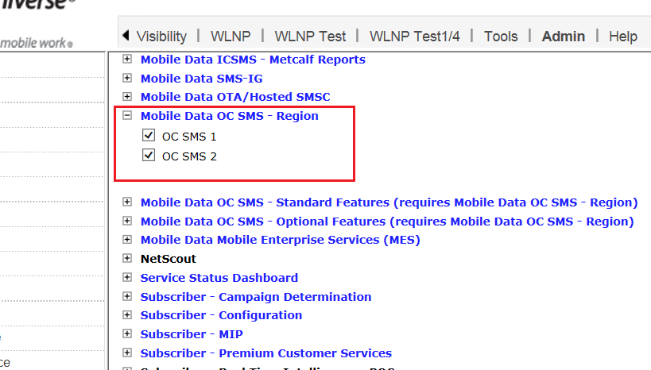

Other than this Syniverse should be having these permissions as well:

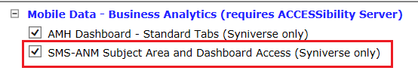

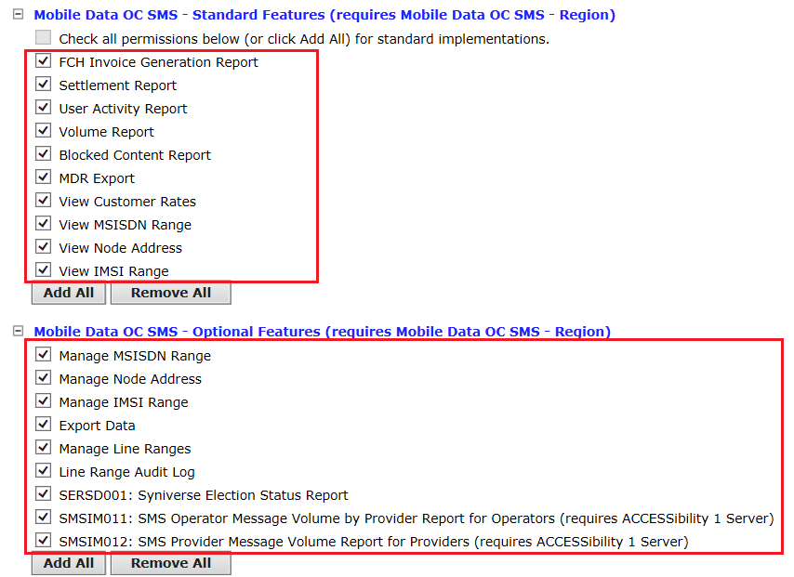

### Syniverse User

For a Syniverse User, please assign all these user permissions OR pick a user who already have the red marked permissions:

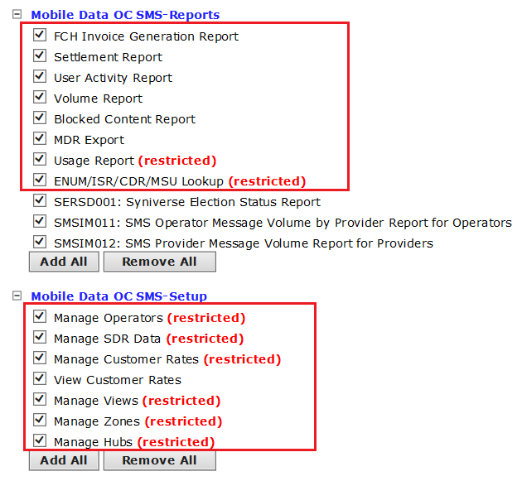

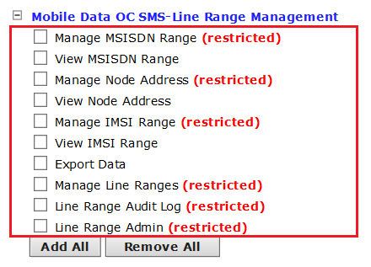

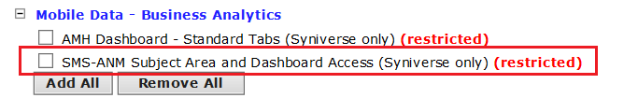

This user should see these links under **Mobile Data** tab. Logically all the links should be clicked and verified if they are showing properly or not.

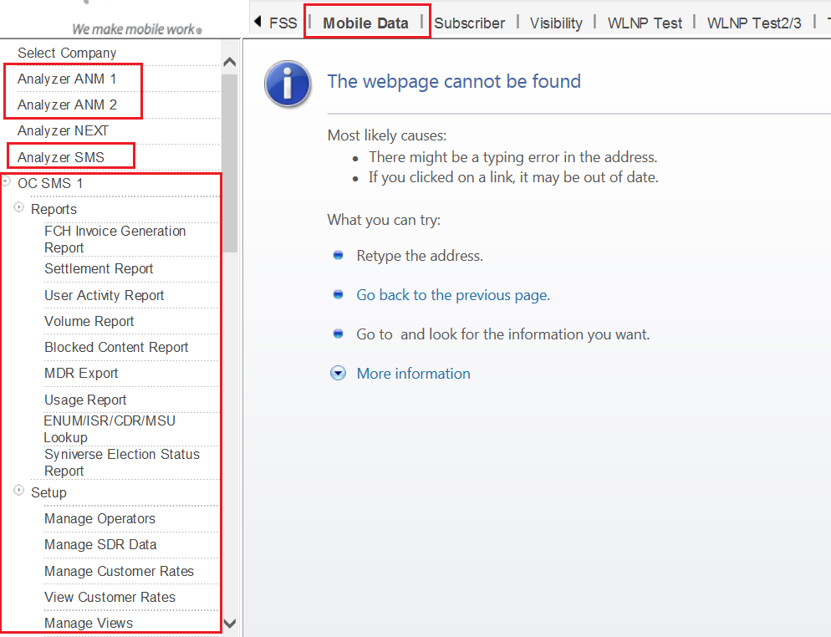

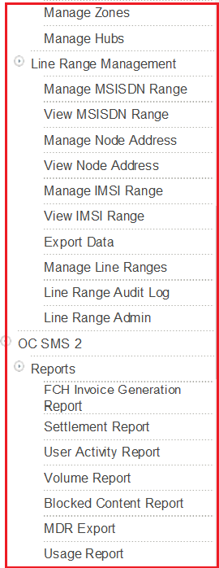

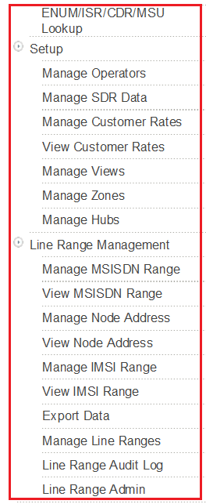

### Customer Test Company

For a Non-Syniverse Test Company , please assign all these company permissions to this Test Company.

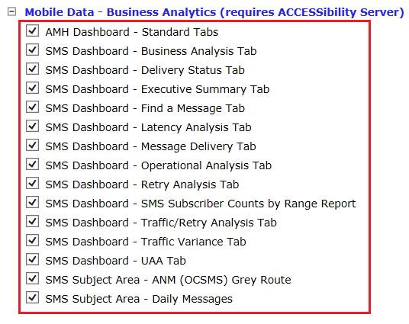

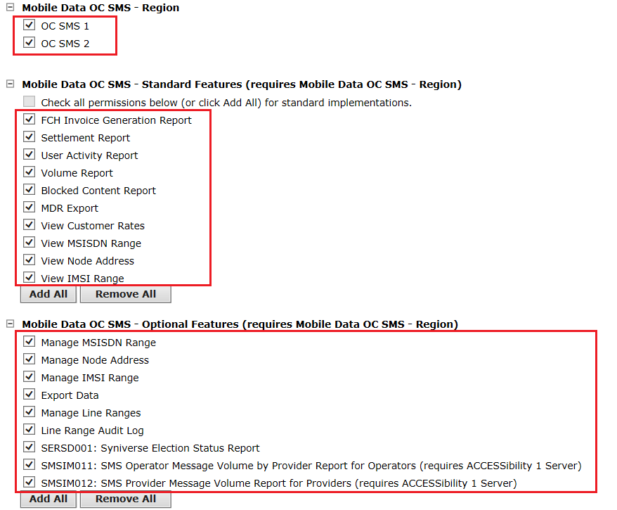

### Customer Test Company User

Assign these user permission to the above test company User.

The green marked permission under **“Mobile Data – Business Analytics”** will bring “Analyzer SMS” link.

The red marked permission “SMS Subject Area – ANM (OCSMS) Grey Route” under **“Mobile Data – Business Analytics”** will bring ANM Analyzer links.

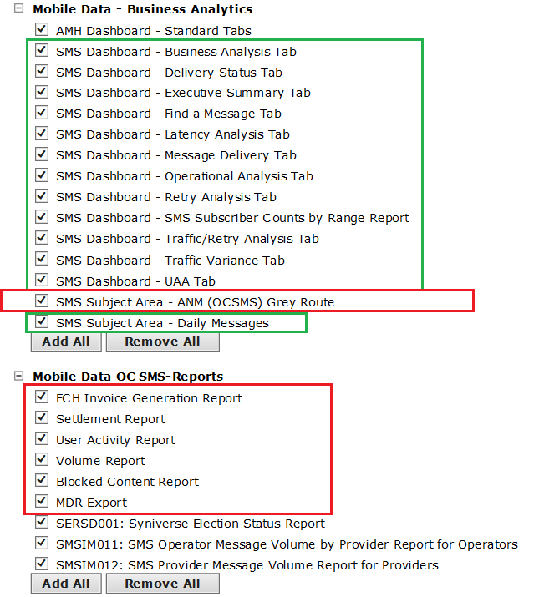

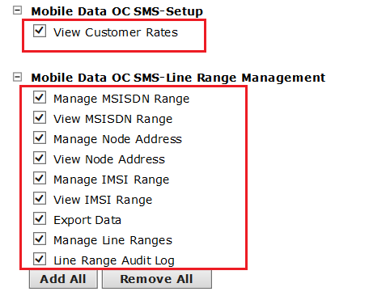

This user should see these links under **Mobile Data** tab. Logically all the links should be clicked and verified if they are showing properly or not.

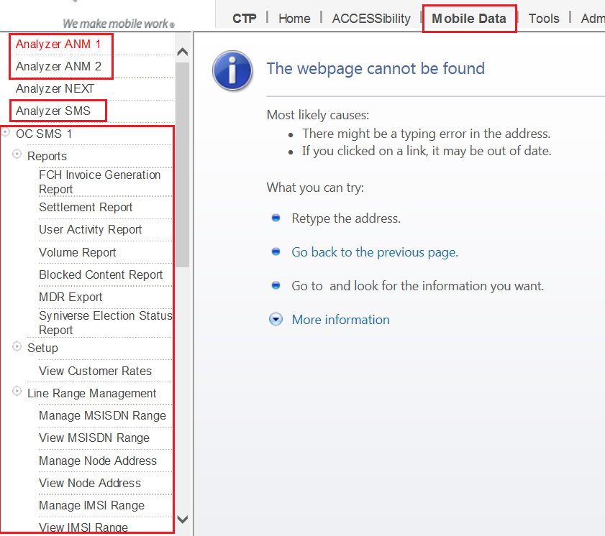

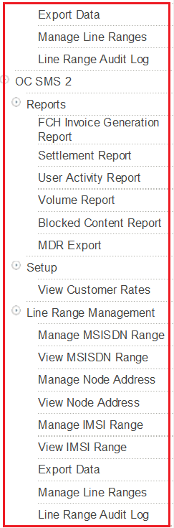

# Test Procedures

Centralized Testing has created a system test plan and executed it in the System Test environment. Please see their documentation and completion report for more information.